3D Weather in the Classroom

**2011 Tornado Outbreak**

**1.Overview**

On April 27th, 2011 over 360 tornadoes occurred due to a cold front associated with a strong mid-latitude cyclone, that extended from the Ohio Valley to southern Texas. The states that experienced the greatest impacts included Alabama, Mississippi, and Tennessee, where 172 of the total tornadoes were reported.

In the 00UTC 300 mb map (Figure 1), a strong jet streak was in place with winds speeds reaching over 100 knots towards the southeast. The jet streak has a strong negative tilt which is typically more conducive for severe thunderstorms and tornadoes.

Ahead of the cold front there was a warm, moist air mass over Mississippi, Alabama, and Tennessee due to strong southerly flow. This warm air mass included high dew point temperatures ranging between 60°F to 70°F to this region indicating that the atmosphere was notably saturated with cold, dry air aloft. The vertical temperature gradient contributes to rising air, increased convection (cloud formation), and potentially severe thunderstorms (Figure 3).

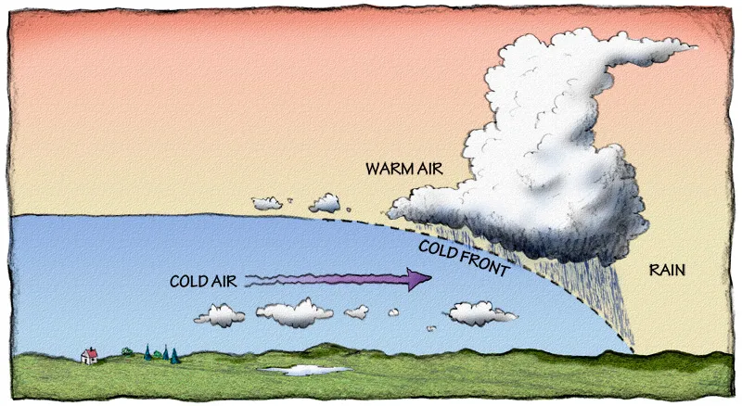

Figure 2. Illustration of a cold front

Meanwhile, the wind speeds at 850 mb increased to between 50 to 55 knots and began flowing more northward. This wind shear (the changing of wind direction with height) is an ingredient for the setup of damaging winds, large hail, and tornado genesis ahead of the cold front. At 4 A.M. the convective line intensified as it progressed into Alabama. The general wind flow at different levels and the unstable conditions supported the formation of scattered supercells with strong rotating updrafts that eventually produced the Super Outbreak.

(b)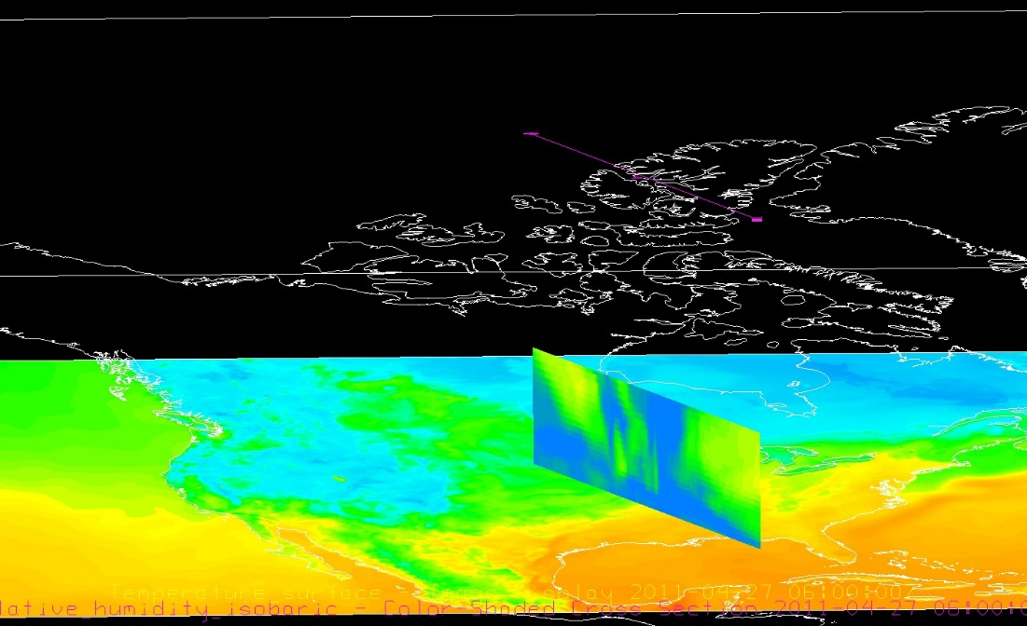

Figure 3. IDV images showing (a) surface temperature gradient, (b) surface relative humidity on April 27, 2011 at 06 UTC.

Images from the associated IDV project illustrate the horizontal surface temperature gradient (Figure 3a) and the vertical profile of relative humidity (Figure 3b). The horizontal temperature gradient shows the definitive line between the cold, dry air mass and the warm, moist air mass. The vertical profile of the relative humidity shows the boundary of the two air masses vertically in the atmosphere by its moisture contents. The abundance of moisture within the warm air mass is conducive for unstable conditions.

(a) 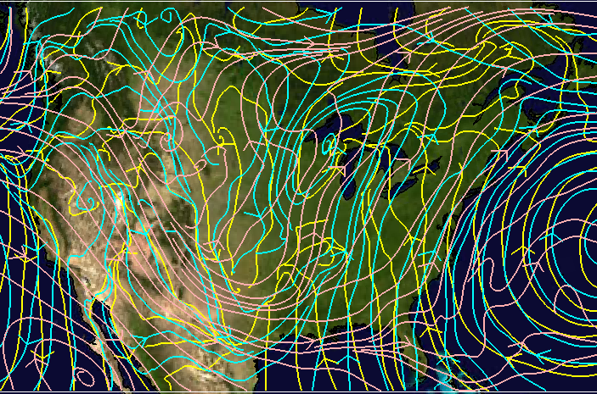

(b)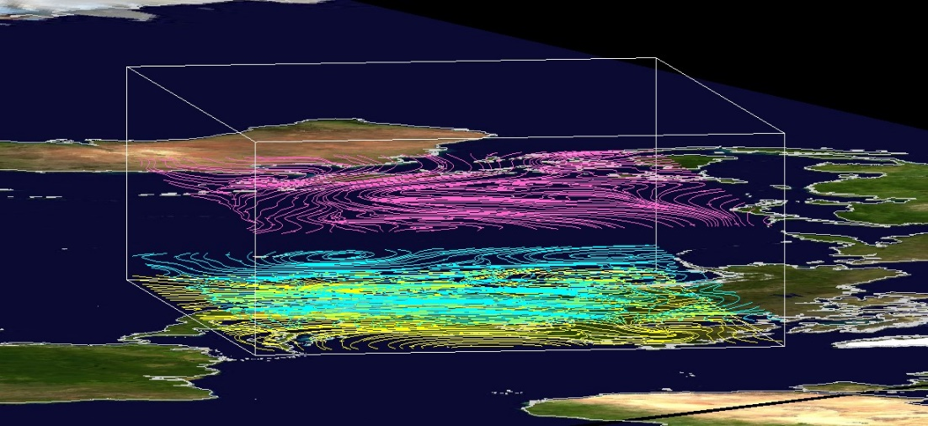

Figure 4. IDV images showing 300 mb (pink), 850 mb (cyan), and 975 mb (yellow) in a plain view (a) and 3D representation. All images are valid for April 27, 2011 at 06 UTC.

As shown in Figure 4a, the wind flow at 975 mb (yellow), 850 mb (cyan), and 300 mb (pink) are stacked, and in Figure 4b, the 4D IDV image is titled to demonstrate the differing wind flows are the varying levels. The varying of wind direction at different heights is wind shear, and this allows the system to form isolated strong rotating updrafts that are conducive for tornadic activity. These fall into the favorable set up for systems that create severe thunderstorms and tornadoes.

With instability and wind shear, the perfect environment for rotating updrafts and tornadic activity is charged. The disastrous tornadoes during the April 27-28, 2011 tornado outbreak occurred periodically throughout the night until 8 A.M. This event is known as the Super Outbreak due to being one of the most damaging and costly tornado outbreaks in recorded history. Having the most fatalities ever reported, 316 people lost their lives due to this event. Researchers use this event to better understand tornado outbreaks today.

**2. IDV Project**

Project filename: “2011TornadoOutbreak.xidv”

* Project data:
  + Filename: “namanl_218_20110427_0600_000.grb”
  + North American Mesoscale (NAM) model April 27, 2021 @ 0600 UTC
  + File retrieved from NOAA operational model page for select levels and variables:
    - NOMADS-NOAA Operational Model Archive and Distribution System
* Displays:
  + Maps
    - World country outlines.
  + Plan views
    - Ground Temperature (°C)
    - Relative humidity 2 meters above ground
  + Flow displays
    - 975 mb streamlines
    - 800 mb streamlines
    - 300 mb streamlines

Features to note:

* + In Figure 3a, the surface temperature highlights where the cold front exists.
    - The location of the boundary between the cold airmass and the warm air mass becomes obvious when looking at surface temperature.
  + In Figure 3b, the vertical relative humidity profile can be seen.
    - With the blue shading representing roughly 100% relative humidity, ahead of where the front exists, the moisture is more concentrated at lower levels within the warm front.
    - Where the frontal boundary exists, the entirety of the column is completely saturated at 100% relative humidity.
    - Behind the front within the cold air mass, the air becomes drier.
  + In Figure 4a, the wind shear exists enabling the severe system to develop into the night.
    - The streamlines at 975 mb overlaid with the streamlines at 800 mb emphasized the changing in wind direction with height.
  + In Figure 4b, given three constant pressure levels (300mb, 800 mb, 975 mb), the wind patterns at these levels can be seen.
    - Wind direction varies at different levels within the vertical profile of the atmosphere.

**3. Knowledge Requirements**

* Module 1-2: Daily and Seasonal Temperature Variations
* Module 3-2: Measures of Moisture
* Module 5-2: Pressure and Wind at Different Atmospheric levels
* Module 5-3: 3D Representation of Pressure and Wind
* Module 7-2: Cold and Warm Fronts

**4. Knowledge Test**

Question 1: Which states experienced the greatest impacts on Aril 27th, 2011?

* A: Alabama
* B: Tennessee
* C: Mississippi
* **D: All of the above**

Question 2: What were the 4 conditions favorable for tornado weather reported by the surface charts?

* **A: (1) southeasterly surface winds, (2) extensive cloud cover, (3) high humidity (temperature and dew point close to the same value), and (4) strong horizontal pressure gradient.**

Question 3: In order for a sever system to form, there must be ______ wind shear.

* **A: high**
* B: moderate
* C: low

Question 4: What kind of air mass was ahead of the cold front over Mississippi, Tennessee, and Alabama?

* A: warm and dry
* B: cold and moist
* **C: warm and moist**
* D: cold and dry

Question 5: What is a supercell?

* A: system with high temperatures and high humidity
* **B: system with strong rotating updrafts**
* C: a tornado
* D: the squall line

Question 6: What leads to unstable conditions favorable for a tornado outbreak?

* A: vertical temperature gradient
* B: high relative humidity
* C: warm air beneath cold air
* **D: All of the above**

Question 7: How many tornados were reported total?

* A: 172
* **B: 360**
* C: 10
* D: 200

Question 8: What are the primary ingredients for severe weather?

* **A: instability and uplift**
* B: high temperatures and low humidity
* C: low temperatures and uplift
* D: anything is possible

Question 9: Where is the source of the cold air mass behind the front?

* A: Tropics
* **B: Polar region**
* C: western U.S.
* D: eastern U.S.

Question 10: How did this cold air mass end up in the southeastern U.S.?

* **A: jet stream**
* B: trade winds
* C: cold front
* D: wind shear